**Customer Churn in Telecom Subscription-based Businesses**

**Group 7:**

**Team Leader:** Hong Khanh Che

**Team Members**: Ankit Malhotra, David Bezhanyan, Zih Yu Chen

**STAT 208 - Spring 24**

**Prof. Wales**

1. **Topics**
2. **Topic Title: Customer Churn in Telecom Subscription-based Businesses**
3. **Topic Motivation:** As subscription models continue to increase, ensuring a consistent revenue stream becomes paramount for telecom companies. Our project proposal analyzes customer churn rates to enhance the management of telecom subscription-based businesses. By predicting customer churn, we aim to identify at-risk clients and devise targeted retention strategies. Additionally, by incorporating CLTV analysis into their business strategies, companies can boost their profitability and enhance their understanding of customer behaviors. Furthermore, our proposal emphasizes the importance of refining products and services to mitigate churn.
4. **Research:** Potential Variables:

* Gender: Different genders may exhibit unique preferences and behaviors related to service usage, impacting their likelihood of churning.
* Income level: Customers with higher incomes might afford more services or higher-tier plans, potentially decreasing their churn rate. Conversely, those with lower incomes might be more sensitive to price changes and more likely to switch if a cheaper alternative is available.
* Age: Younger customers might be more prone to churn due to their comfort with technology and ease of switching providers. Older customers might value stability and customer service, potentially leading to lower churn rates.
* State: Geographic location can affect churn due to regional economic conditions, competition among service providers, and even differences in service quality or availability in certain areas.
* Marital Status: Married customers or those in stable relationships might have different needs and financial situations than single customers, affecting their likelihood of staying with or leaving a provider.
* Dependent: Having dependents might influence customer decisions on telecom services, prioritizing reliability and cost-effectiveness, which could reduce churn.
* Number of lines: Customers with multiple lines might be families or businesses, which are typically more stable and have a lower churn rate due to the hassle of switching multiple lines.
* Subscription fee (Total charge): High costs can be a significant driver of churn, especially if customers feel they are not receiving value proportional to the price or if competitive, cheaper options are available.
* Liability (Yes/No): If a customer has liabilities such as loans or mortgages, they might be more cost-conscious, influencing their decision to continue or terminate services based on financial pressure.
* Promotion: Promotional activities can either retain customers by offering added value or prompt churn if customers perceive promotions are better elsewhere or if they feel mistreated once a promotional period ends.
* Employed (Yes/No): Employment status can affect a customer’s ability to afford services. Unemployed individuals might need to cut costs, including switching telecom providers.
* Active Account (Yes/No): An active account typically indicates regular use and engagement with the service, potentially decreasing the likelihood of churn.
* Activity Period: The length of time a customer has been with a service can indicate loyalty; longer periods might suggest lower churn risk, whereas newer customers might still be evaluating their options.
* Churn Value (Yes/No) Potential dependent variable: This is the dependent variable we’re predicting. It directly represents whether a customer has left the service, helping understand the impact of various factors on retention.

1. **Research Objectives:**
2. **Objective 1:** Identify the main reasons for customer churn and reduce churn by identifying potential switchers.

Reason for choosing: The churn rate directly impacts revenue and profits. Understanding the factors influencing it will help develop strategies to reduce customer churn and retain valuable customers.

1. **Objective 2:** Develop new products and efficient marketing campaigns by understanding customer behavior trends. This understanding will not only improve the experience of existing customers but also attract potential customers, thereby benefiting telecom subscription-based businesses.

Reason for choosing: Improving customer service will build long-term loyalty, increasing

our competitive advantage. Besides, predicting customer churn also helps increase

revenue growth by increasing long-term valuable relationships and maximizing lifetime

customer value.

1. **Exploratory Data**
2. **Data Overview**

The potential data is fictitious data of a telecommunications company providing phone and

Internet services containing 7043 observations with 33 variables. Data contains a variety of data

types, so we can categorize them based on their types and purposes as follows:

**Customer Identification**

| **Variable** | **Description** | **Type** |
| --- | --- | --- |
| CustomerID | A unique ID that identifies each customer. | Identifier |
| Count | Number of customers in a set. | Metric |
| Country | Customer's primary country of residence. | Geographic |
| State | Customer's primary state of residence. | Geographic |
| City | Customer's primary city of residence. | Geographic |
| Zip Code | Customer's primary zip code. | Geographic |
| Lat Long | Combined latitude and longitude coordinates. | Geographic |
| Latitude | Latitude of the customer’s residence. | Geographic |
| Longitude | Longitude of the customer’s residence. | Geographic |

### Demographic Information

| **Variable** | **Description** | **Type** |
| --- | --- | --- |
| Gender | Customer's gender (Male, Female). | Categorical |
| Senior Citizen | Indicates if the customer is 65 or older (Yes or No) | Categorical |
| Partner | Indicates if the customer has a partner (Yes or No) | Categorical |
| Dependents | Indicates if the customer has dependents (Yes or No) | Categorical |

### Service Subscription Details

| Variable | Description | Type |
| --- | --- | --- |
| Phone Service | Subscription to home phone service (Yes or No) | Categorical |
| Multiple Lines | Subscription to multiple telephone lines (Yes or No) | Categorical |
| Internet Service | Type of Internet service subscribed to (No, DSL, Fiber Optic, Cable). | Categorical |
| Online Security | Subscription to online security service (Yes, No, or No internet service) | Categorical |
| Online Backup | Subscription to online backup service (Yes, No, or No internet service) | Categorical |
| Device Protection | Subscription to a device protection plan (Yes, No, or No internet service) | Categorical |
| Tech Support | Subscription to a tech support plan with reduced wait times (Yes, No, or No internet service) | Categorical |
| Streaming TV | Uses Internet service to stream TV without an additional fee (Yes, No, or No internet service) | Categorical |
| Streaming Movies | Uses Internet service to stream movies without an additional fee (Yes, No or No internet service) | Categorical |
| Contract | Type of customer contract (Month-to-Month, One Year, Two Year). | Categorical |
| Paperless Billing | Whether the customer has chosen paperless billing (Yes or No) | Categorical |
| Payment Method | How the customer pays their bill (Bank Transfer, Credit Card, Mailed Check, Electronic Check). | Categorical |

### Financial Information

| Variable | Description | Type |
| --- | --- | --- |
| Monthly Charge | The current total monthly charge for all services. | Numerical |
| Total Charges | Total charges are calculated at the end of the quarter specified. | Numerical |
| CLTV | Customer Lifetime Value is predicted using corporate formulas. The higher the value, the more valuable the customer. High-value customers should be monitored for churn. | Numerical |

### Churn Information

| Variable | Description | Type |
| --- | --- | --- |
| Churn Label | Indicates if the customer left the company this quarter (Yes or No) | Categorical |
| Churn Value | Indicates churn status ( Yes = 1 = left, No = 0 = remained). | Categorical |
| Churn Score | Score from 0-100, indicating the likelihood of churn. The higher the score, the more likely the customer will churn. | Numerical |
| Churn Reason | Customer's specific reason for leaving the company. | Categorical |

1. **Data Gaps:**

We found two data sets that mostly met our requirements with potential variables as outlined above. However, some gaps in the data were also found below, which might affect our analysis and evaluation and the resolution of the objectives.

* Limited Scope of Variables: This dataset doesn't include enough potential variables, such as promotions, employment status, income level, and service modification, as expected. These indicators relevant to the study can limit the depth of analysis and be an obstacle to evaluating how building a promotional strategy affects customer retention or switching.
* Geographical limitations: Limited data on locations, specifically solely in California, USA, might skew understanding of infrastructure challenges or successes in different terrains or urbanization levels because the state's geography varied from coastal areas to mountainous regions.
* Incompleteness in Analysis: The absence of a CLTV calculation method can hinder deep analytical insights that are crucial for strategic decision-making. CLTV helps us understand customer profitability, guide marketing spending, and optimize customer relationship management strategies.

1. **Data Visualization**
2. Visualization for Categorical Variables

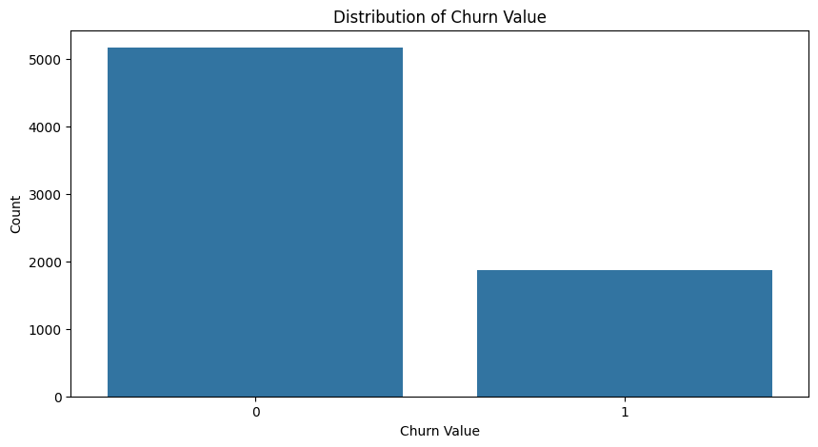

A significantly larger number of customers have remained with the company compared with fewer customers who have left. At the time of this dataset collection, the company retained more customers than it lost, as the ratio of non-churning customers (73.5%) is much higher than that of churning customers (26.5%). The imbalance shown in the chart might indicate the need for further analysis to understand why certain customers are leaving and potentially to develop strategies to reduce churn.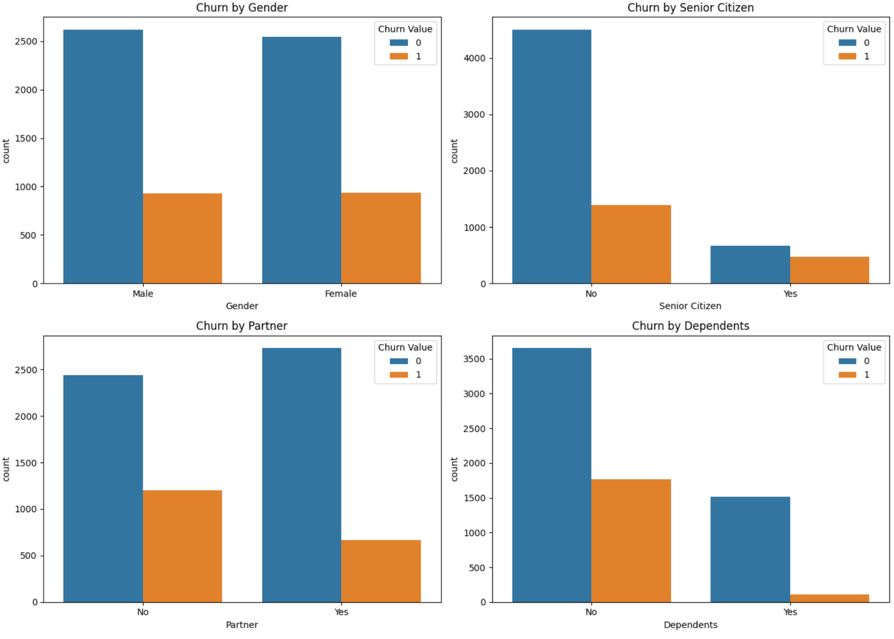

Gender does not appear to be a significant differentiator in churn compared to churn customers and loyalty customers, as the patterns are quite similar across both genders.

For partner indicators, having a partner may be associated with lower churn rates, possibly due to shared financial responsibilities or joint decision-making in service selection and retention.

Senior citizen status is a significant factor in churn, with seniors more likely to leave the service. This might be due to different needs, pricing sensitivities, or service preferences. This result makes sense, as we expect, since senior citizens prefer stability.

Having dependents might lower the likelihood of churn. This could be related to the stability needed in service provision or the higher barriers to changing services due to family needs.

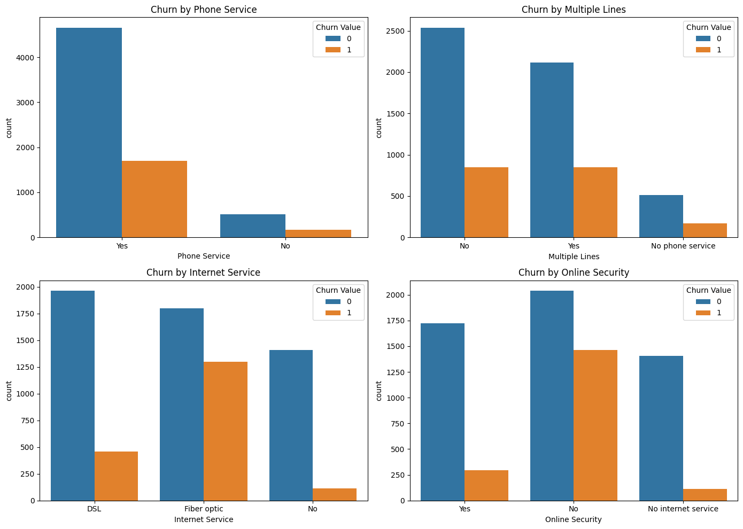

For phone service, a significant majority (85%) of the data have a phone service subscription (Yes), while only 15% do not (No). Additionally, there is a noticeable difference in the count of phone service subscriptions between the two categories (non-churning 0 and churning 1). Non-churning customers have a much higher count of phone service subscriptions compared to churning customers.

For multiple lines, the "No phone service" column in the data does not actually indicate the absence of multiple lines. Still, it indicates that the individual does not have phone service at all. Among phone service subscribers, a slight majority (53%) have multiple lines (Yes), while 47% do not (No). Churning customers are evenly distributed among multiple phone lines, with no clear preference. This suggests that the number of phone lines may not be a determining factor in customer churn.

For internet service, the majority (54%) of non-churning customers use Fiber optic internet, followed by DSL (34%) and no internet (12%). In contrast, the majority (59%) of churning customers use Fiber optic internet, followed by DSL (21%) and no internet (5%). This suggests that fiber optic internet may be a valuable retention factor, and offering reliable and high-speed internet services could help reduce customer churn.

For online security, online backup, device protection, tech support, streaming TV, and streaming Movies, the "No Internet service" column in those data sets is essentially a subset of the "No" column in the "Internet Service" data, indicating that those individuals do not have internet service and therefore cannot have the respective services.

Among customers with internet service, a majority (63%) of them do not have online security. Churning customers are more likely not to adopt online security, as 78% of churning customers do not have Online Security, compared to 39% of non-churning customers.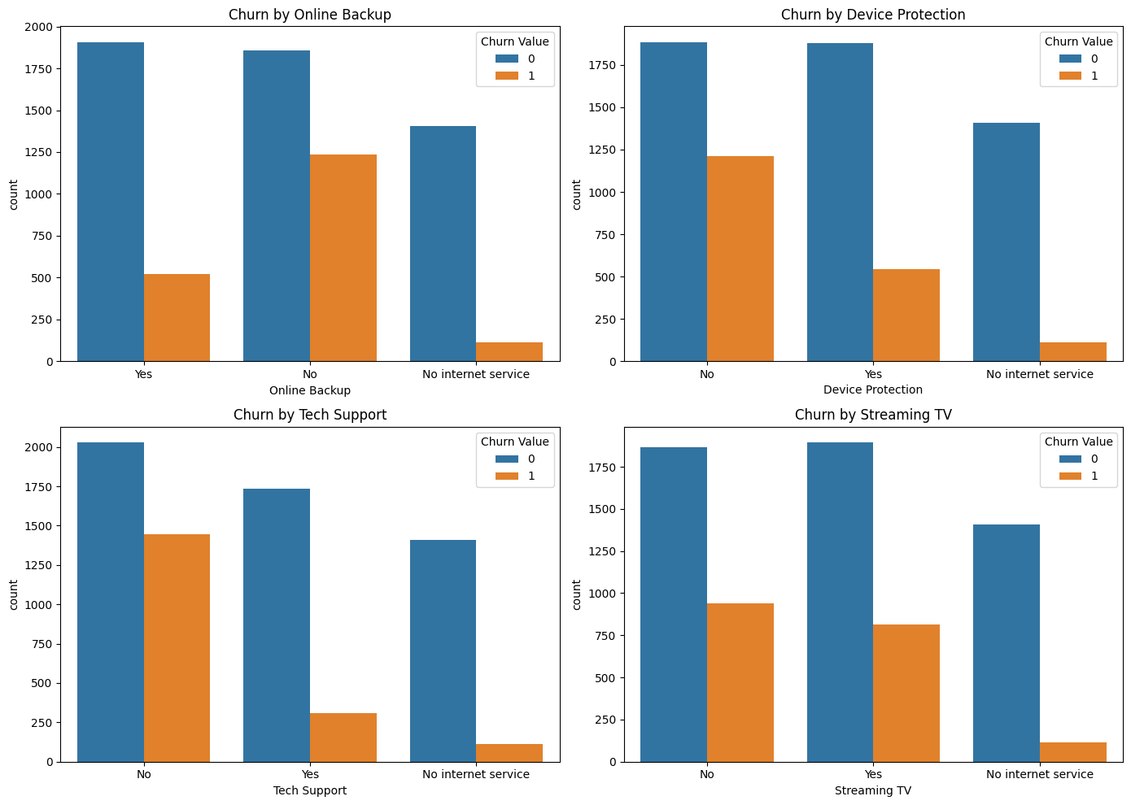

Across online backup, device protection, and tech support services, adoption rates are roughly evenly split among customers. However, a significant majority (around 70%) of churning customers choose not to use these services, compared to a smaller proportion (around 30%) of non-churning customers. This insight suggests that churning customers may be less invested in their digital well-being, potentially leaving them vulnerable to data loss, security breaches, and technical issues. By offering these services and highlighting their value, we may improve customer satisfaction, reduce churn risk, and increase revenue.

Based on the similar patterns in the graphs for Streaming TV and Streaming Movies, as well as the similar subscription graphs, it appears that subscription to these services may not be a significant factor in determining whether a customer churns or not.

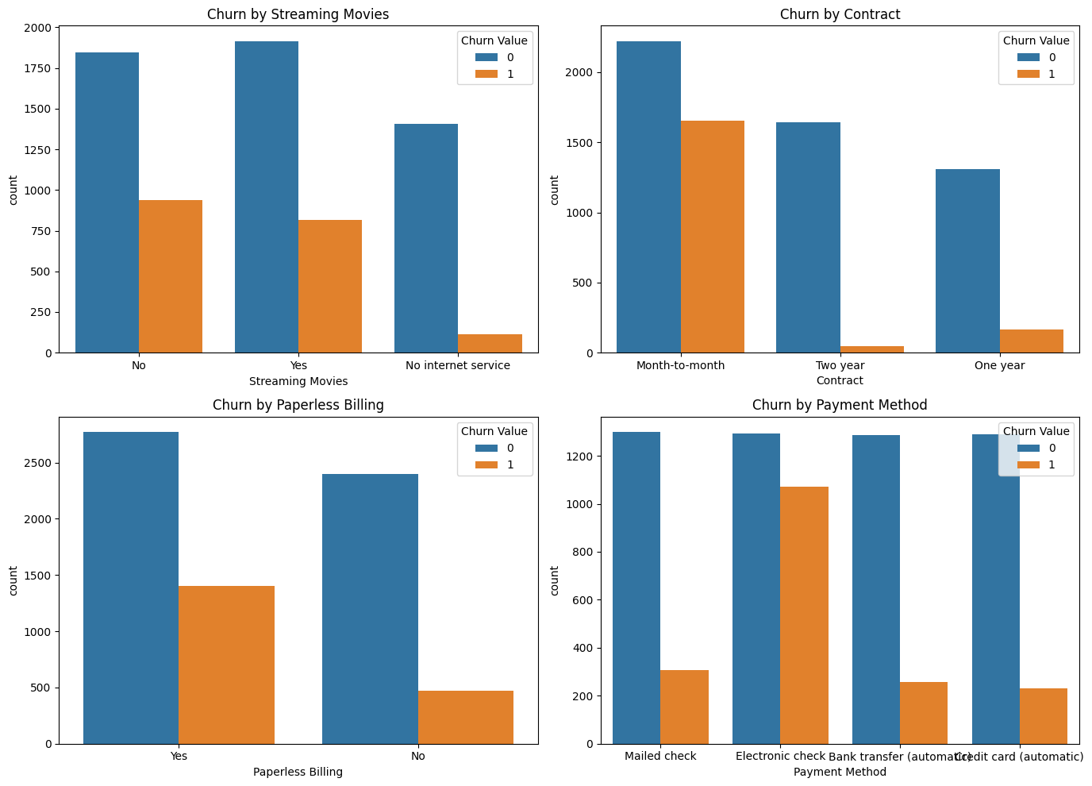

The majority of non-churning customers have opted for longer contract periods. In contrast, churning customers predominantly have month-to-month contracts, with 89% choosing this option. This suggests that offering longer contract periods may be a strategy to reduce churn risk, as customers who commit to longer contracts are more likely to remain loyal.

Most non-churning customers (54%) have adopted paperless billing, and an even larger majority of churning customers (75%) have also chosen this option. This suggests that the convenience and flexibility of paperless billing may not be enough to retain customers. Churning customers may be more tech-savvy or appreciate the environmental benefits of digital bills but ultimately leave due to other factors such as pricing, service quality, or overall customer experience.

Non-churning customers have a relatively even distribution across payment methods. In contrast, churning customers predominantly use electronic checks, with 57% using this method. Churning customers' preference for non-automatic payment methods suggests they may value control over their payments, closely manage their finances, or have trust and security concerns. They might prefer manual payments to ensure they only pay when they have sufficient funds or to maintain flexibility in case of payment schedule changes.

The original tenure in months has been transformed into tenure groups, dividing the data into six distinct categories: 0-12 months, 12-24 months, 24-36 months, 36-48 months, 48-60 months, and 60-72 months. The bar chart illustrates the number of customers who have churned versus those who have not across various tenure groups. The tenure groups are divided into six ranges, each spanning 12 months. A significant proportion of these customers have churned, indicating that the first year is critical for customer retention. Hence, maintaining and nurturing long-term relationships with customers is essential, as evidenced by the low churn rates in the 60-72-month group.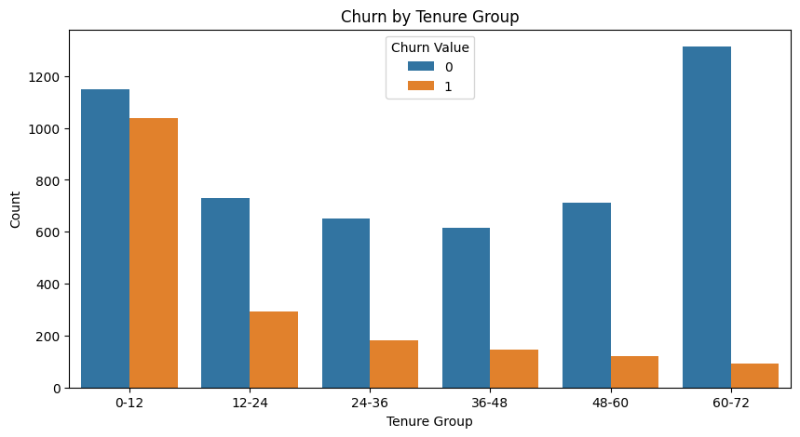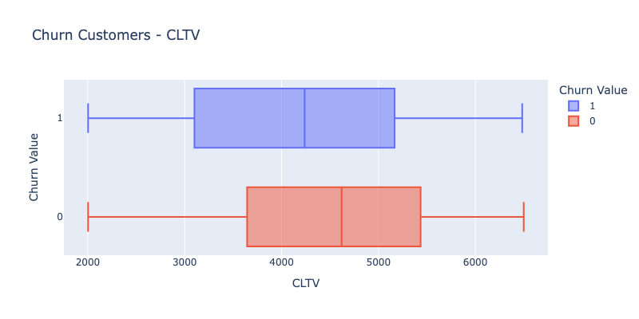

The median and interquartile range CLTV for retained customers appears higher than for those who are left, suggesting these customers generally have higher CLTVs but less variability in their CLTV compared to those who are left. This boxplot indicates that lower CLTV is associated with higher churn risk, which is logical.

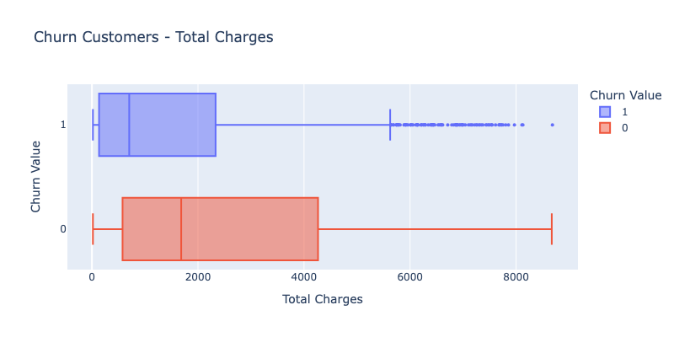

Churned customers tend to have a lower median total charge compared to those who have not churned. The range for churned customers' total charges is less variable and mainly concentrated on the lower end of the scale, suggesting these customers might be spending less before churning. Retained customers show a higher median and a more comprehensive range in total charges, indicating a broader spread in how much they spend. This boxplot also shows that the low spending of customers who have left, on average, indicates that current customers are likely to leave in the future by reducing their spending on services. Additionally, this variable shows that the cost of services is not a significant factor in their leaving because those who left pay less on average than those who stayed.

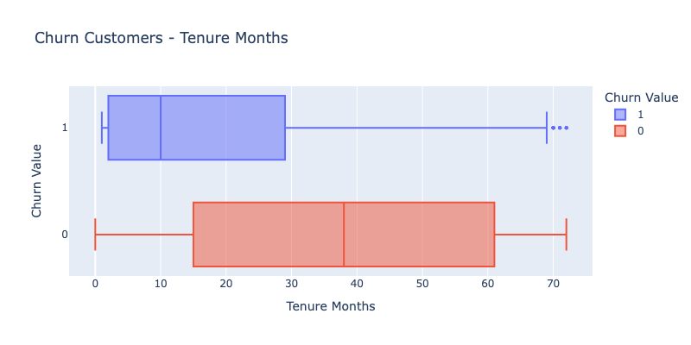

This boxplot helps identify trends related to customer longevity and churn. Like CLTV, customers with shorter tenures are likelier to churn, suggesting the importance of early engagement and retention strategies and understanding why customers with long tenures still churn could reveal insights into potential service or satisfaction issues that might arise over time.

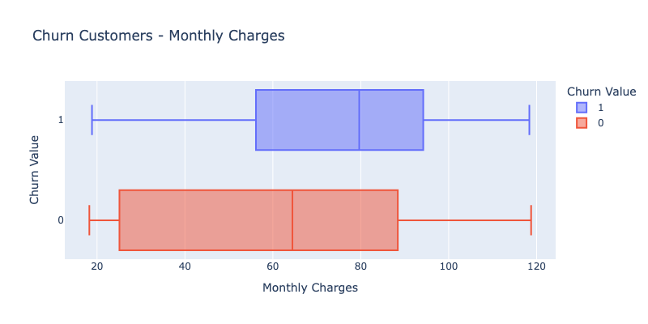

Churned customers generally have higher monthly charges, indicated by a higher median and a broader spread than retained customers. The distribution suggests that higher monthly charges may correlate with an increased likelihood of churn. This insight can help refine pricing strategies to reduce churn rates, perhaps by adjusting pricing tiers or introducing more customized billing options to retain customers at risk of churning due to high costs.

**Total charges - Monthly charges**: Total charges are cumulative and reflect the entirety of a customer's financial relationship with a service over time. Consequently, retained customers typically show higher total charges as they remain subscribed longer, thus allowing their charges to accumulate. In contrast, monthly charges represent a customer's regular expenses from using the service. The data shows that churned customers tend to have higher monthly charges, possibly due to being on more expensive plans or having additional service charges that increase their monthly financial commitment. This disparity suggests that while churned customers often face higher immediate costs, their shorter tenure prevents these costs from accumulating to the levels seen in retained customers. This pattern highlights the impact of cost perception on customer retention, where higher monthly charges may deter long-term commitment, leading to churn despite the potentially lower cumulative financial outlay.

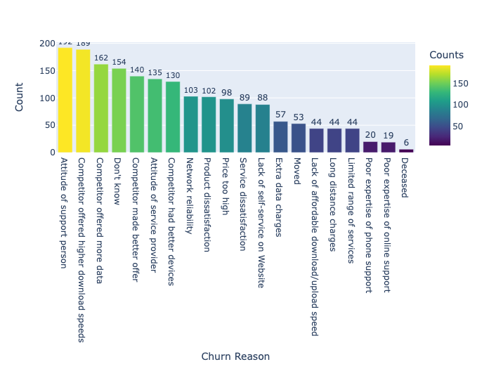

As mentioned above, regarding the analysis of satisfaction and service issues, we plot churn reasons to get a clearer view of customers leaving. We remove the blank cells, representing the customers who stayed, keep values with the reason for leaving, and get the results shown in the chart above. The reason we think of is for service cost, which is also mentioned above with the monthly charges variable. However, according to the chart, the top 7 main reasons are the Attitude of the support person, the competitor offering higher download speeds, the Competitor offering more data, the competitor making better offers, and the Attitude of the service provider, indicating that the service attitude and competitors groups are the main reasons customers leave the company.

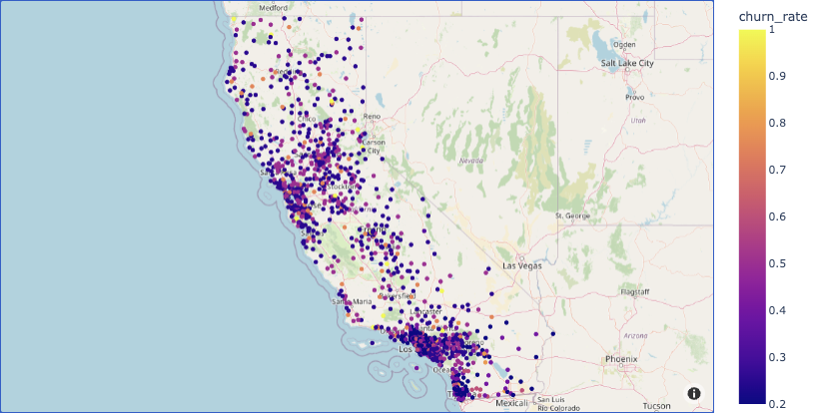

With the Longitude and Latitude variables, we plot a map showing the distribution of churn rates across cities in California. The concentration of purple dots along specific areas, primarily in major urban centers within California like Los Angeles and San Francisco, San Jose might suggest higher churn rates in these regions. These areas may require targeted interventions to improve customer satisfaction and reduce churn. Lighter colored dots in more rural or less densely populated areas might indicate lower churn rates, which could be due to less competitive markets or different customer demographics.

1. Visualization for Numerical Variables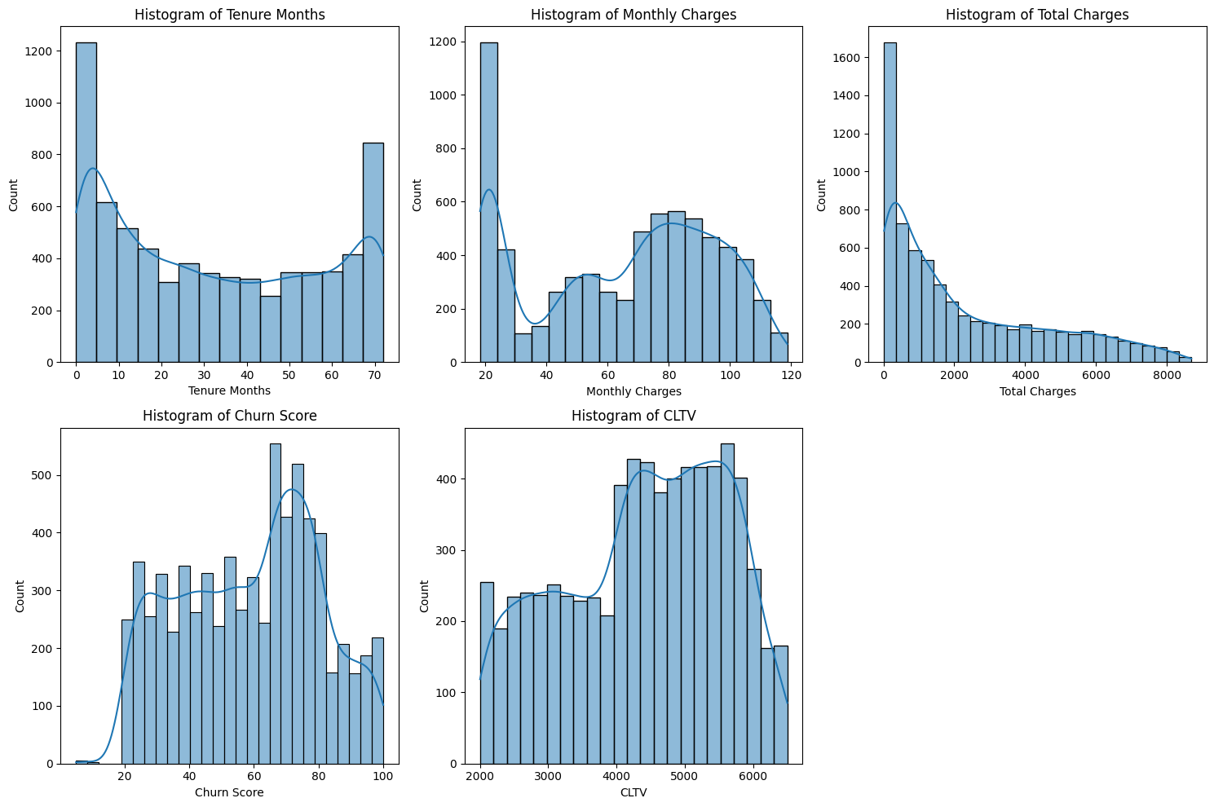

The histogram of tenure months shows a U-shaped distribution, indicating a bimodal pattern. The majority of customers (highest peak) use the service for a short duration of 0-5 months, while a significant proportion (second highest peak) maintain usage for an extended period of around 65-70 months. Notably, there is a prominent trough between 6-64 months, suggesting relatively few clients use the service for a mid-term duration. This distribution may hint at distinct customer segments with varying needs and behaviors, warranting further investigation to understand their preferences and optimize the service accordingly.

The histogram of monthly charges appears to have a complex, irregular shape, with multiple peaks and troughs. It peaks at $20, then drops significantly to $25. The trend continues downward, hitting a valley at $30. Another peak occurs at $80 but ultimately falls to $120. This shape suggests that there are multiple distinct groups or clusters of customers with different monthly charge patterns rather than a simple, smooth distribution.

The histogram of total charges is right-skewed, indicating that most data points are concentrated on the lower end of the scale. It peaks between $0-800, suggesting that a large majority of customers have total charges within this range. As the charges increase beyond $800, the number of instances decreases steadily, forming a long tail. This right-skewed distribution indicates that a few customers have significantly higher total charges, but most customers have relatively lower charges.

The histogram of churn scores exhibits an irregular shape, with a platform-like structure between 20-60, indicating a relatively flat distribution in this range. It peaks around 65, suggesting a high concentration of clients with churn scores in this range.

The histogram of CLTV features two distinct platform-like structures. The first platform spans from $2000 to $4000, and the second platform occurs between $4000 and $6000, indicating a separate cluster of high-value customers. This distribution suggests the presence of two distinct client segments with different purchasing behaviors.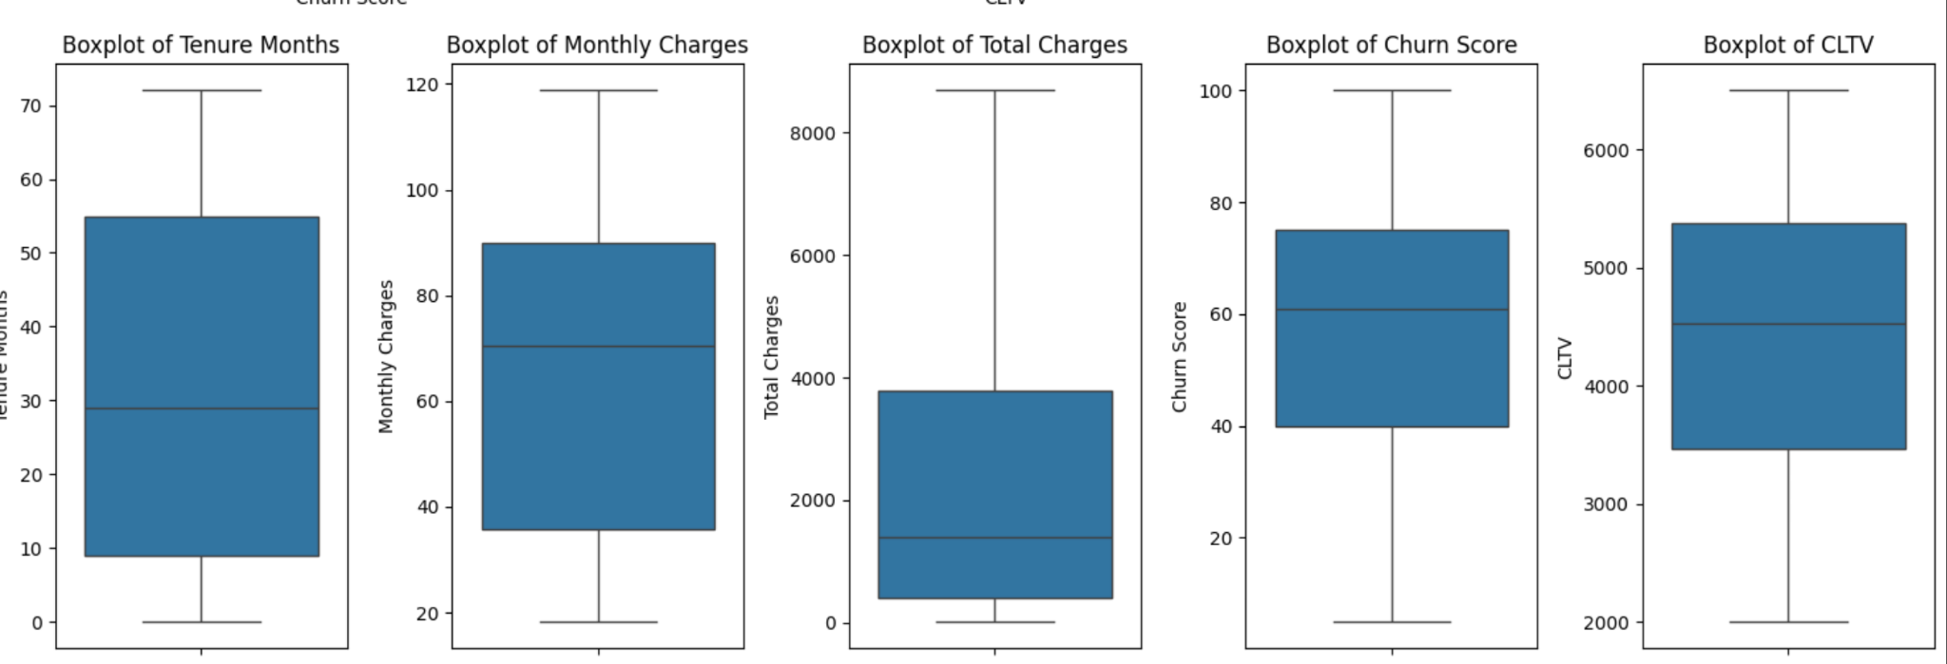

The median tenure is around 30 months. The IQR spans approximately 10 to 55 months, indicating a wide distribution regarding how long customers stay. This spread suggests variability in customer loyalty or satisfaction, indicating segments of very loyal customers.

Monthly charges have a median of around $70 and range from about $20 to $120, indicating diverse pricing plans or service levels. The wide range suggests a variety of service offerings, from basic to premium. The even distribution across this range indicates a balanced customer base across different service levels.

Total charges show a median of nearly $2,000 with a long right tail. The variation in total charges likely reflects differences in both tenure and monthly charges. Higher outliers may represent long-term customers with higher monthly rates.

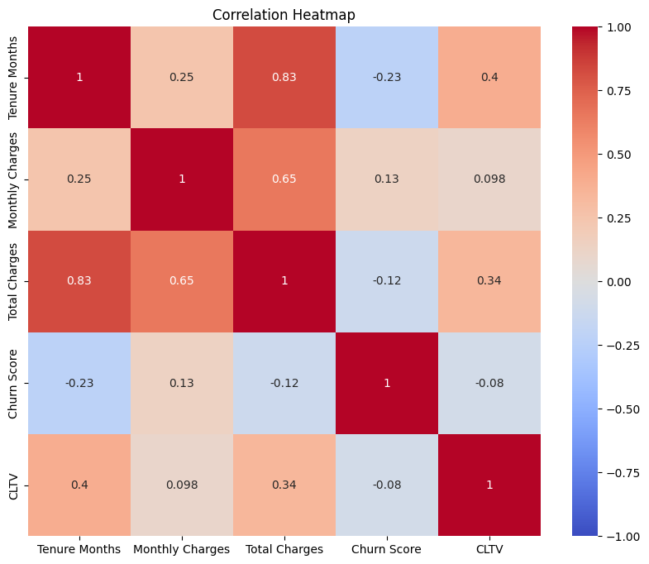

* CLTV and Tenure Months (0.4): This is a moderate positive correlation. It suggests a reasonable relationship where longer tenures are associated with higher CLTV, which is expected since long-term customers typically generate more revenue.
* CLTV and Monthly Charges (0.098): This weak positive correlation indicates that monthly charges slightly impact CLTV. This suggests that increasing monthly charges alone isn't very effective at increasing a customer's lifetime value, possibly because higher charges could lead to higher churn rates.
* CLTV and Total Charges (0.34): This moderate correlation is sensible as it suggests that higher total charges accumulated over time correlate positively with higher CLTV. This aligns with the idea that customers who spend more over their tenure are more valuable in terms of lifetime value.
* CLTV and Churn Score (-0.08): The weak negative correlation here is not strong enough to draw significant conclusions but does indicate that the higher likelihood of churn slightly lowers CLTV, which is logical.

From the heatmap, we can conclude that CLTV's strongest correlations are with tenure and total charges; its relatively weak correlation with monthly charges and churn score suggests that simply increasing rates or focusing on churn prediction scores might not be the most effective strategy for maximizing CLTV. Instead, efforts to enhance customer retention and increase tenure, possibly through improved customer satisfaction and value offerings, may be more beneficial for boosting CLTV.

1. **Data Modeling**
2. **Model Summary**

As mentioned in the project proposal, the models we recommend to solve the objectives are k-means, regression models, and decision trees. After testing different models, we only keep the models that give the best results based on criteria such as Accuracy and F1-score. We removed the linear regression model for CLTV because the R-squared result was quite low, which was 0.16 low compared to the expectation. We only focus on the models that predict customer churn, which are shown in the following table:

| **Model** | **Accuracy** | **Precision** | **Recall** | **F1 Score** |
| --- | --- | --- | --- | --- |
| Logistic Regression (After SMOTE) | 0.78 | 0.59 | 0.76 | 0.66 |
| Random Forest (After SMOTE) | 0.78 | 0.59 | 0.66 | 0.62 |
| SVM with Linear Kernel | 0.81 | 0.69 | 0.57 | 0.62 |
| SVM with Polynomial Kernel | 0.8 | 0.72 | 0.48 | 0.57 |
| SVM with RBF Kernel | 0.81 | 0.71 | 0.51 | 0.59 |
| SVM with RBF Kernel (After Hyperparameter Tuning) | 0.81 | 0.71 | 0.56 | 0.63 |
| SVM with RBF Kernel (After Feature Engineering) | 0.79 | 0.65 | 0.52 | 0.58 |
| Neural Network | 0.78 | 0.61 | 0.62 | 0.61 |

### 

### 

### 

### Model Interpretation

### **Best Model Based on Accuracy:** SVM with Linear Kernel and SVM with RBF Kernel (After Hyperparameter Tuning) both have the highest accuracy at 0.81.

**Best Model Based on Precision for Churn (Class 1):** SVM with Polynomial Kernel has the highest precision for churn (0.72).

**Best Model Based on Recall for Churn (Class 1):** Logistic Regression (After SMOTE) has the highest recall for churn (0.76).

**Best Model Based on F1 Score for Churn (Class 1):** Logistic Regression (After SMOTE) has the highest F1 score for churn (0.66), indicating the best balance between precision and recall.

**K-means clustering interpretations**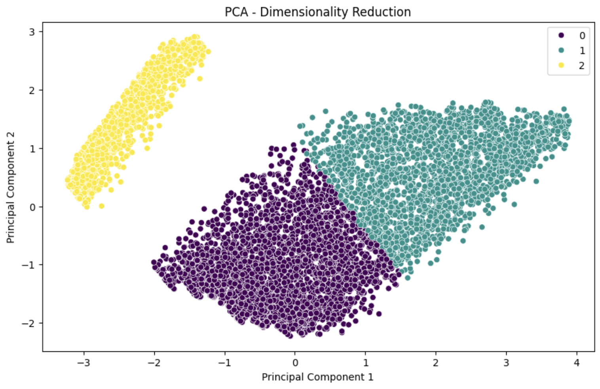

* **Cluster 0**:
  1. Customers in this cluster have lower monthly and total charges.
  2. The tenure of these customers is generally shorter.
  3. There is an equal distribution of male and female customers.
  4. Most customers are not senior citizens and do not have partners or dependents.
* **Cluster 1**:
  1. Customers in this cluster have higher monthly and total charges.
  2. The tenure of these customers is generally longer.
  3. There is an equal distribution of male and female customers.
  4. This cluster has a balanced mix of senior and non-senior customers and a higher proportion of customers with partners and dependents.
* **Cluster 2**:
  1. Customers in this cluster have very low monthly and total charges.
  2. The tenure of these customers is generally moderate.
  3. There is an equal distribution of male and female customers.
  4. Most customers are not senior citizens and do not have partners or dependents.

### Model Evaluation

**Logistic Regression (After SMOTE)** is the best model if your priority is to maximize the recall and have a good balance between precision and recall (F1 Score).

**SVM with RBF Kernel (After Hyperparameter Tuning)** and **SVM with Linear Kernel** are the best models if your priority is overall accuracy and a good balance between precision and recall.

If the goal is to identify as many churn cases as possible (high recall), go with Logistic Regression (After SMOTE).

If you prefer a model with higher accuracy and balanced performance (good precision and recall), SVM with RBF Kernel (After Hyperparameter Tuning) or SVM with Linear Kernel are suitable choices.

1. **Conclusions / Recommendations**

After exploring and analyzing the historical data, we found some reasons for people leaving, such as the higher cost of fiber services compared to alternatives, unmet high expectations for service quality, intense competition from other providers offering similar services at lower prices, and a demographic profile that includes younger, tech-savvy users who are more prone to switching providers. We conduct some models to determine which variables are important to consider when solving objectives.

Among all the models, the Support Vector Machine (SVM) with the RBF kernel, particularly after hyperparameter tuning, achieved the best overall performance with high accuracy (0.81) and a balanced F1 score (0.63). This suggests that SVM with the RBF kernel is well-suited for this classification task. However, considering the complexity of implementation and computational resources, logistic regression also remains a viable option due to its simplicity and strong recall performance.

Based on the logistic regression, SVM, and random forest model results, the following variables are commonly identified as important in influencing customer churn:

* Total and Monthly Charges
* Internet Service (Fiber Optic)
* Tenure Months
* Dependents

1. **Total and Monthly Charges:**

Higher charges are a significant factor contributing to customer churn. Customers paying more are more likely to leave, possibly due to the perceived lack of value for money or financial constraints. We recommend introducing tiered pricing plans that offer more flexibility and better value for different usage levels. Moreover, providing loyalty discounts or bundled services will give more for less, thus reducing the perceived financial burden. Regularly reviewing and adjusting billing practices will ensure fairness and transparency. Implementation of bill smoothing strategies will help manage large fluctuations in charges. Other strategies include implementing a referral program that rewards customers for bringing in new subscribers. By implementing these strategies, telecom companies can demonstrate a commitment to customer satisfaction and loyalty, reducing churn and driving business growth.

1. **Internet Service (Fiber Optic):**

Customers with fiber optic internet services have a higher likelihood of churning, which might be due to issues with service quality, pricing, or unmet expectations regarding the speed and reliability of fiber optic connections. To address this, companies should enhance customer support specifically for fiber optic users by resolving common technical issues and providing proactive maintenance. Offering satisfaction guarantees or trial periods for new customers and regularly collecting feedback will continually improve service quality. Additionally, fiber optic-specific strategies such as providing detailed information on fiber optic speeds and reliability, offering flexible data plans, and regular network upgrades will help to meet customer expectations and reduce churn.

1. **Tenure Months:**

Customers with longer tenures are less likely to churn, indicating that loyalty builds over time and that longer-term customers are more satisfied or more entrenched in the service. Implementation of loyalty programs that reward long-term customers with discounts, exclusive offers, or early access to new features will have a positive impact on customer churn rate. Another way to strengthen customer relationships is recognition and celebration of customer milestones (e.g., anniversaries), offering milestone rewards for customers who reach certain tenure milestones, such as exclusive discounts on monthly charges after one year, free upgrades to higher-tier plans after two years, and complimentary premium content subscriptions after five years. Provide personalized support and account management for long-tenure customers, including dedicated customer support agents, regular account reviews and recommendations, personalized offers and discounts, proactive resolution of technical issues, and enhanced security features and monitoring.

1. **Dependents:**

Customers with dependents show different churn behavior, possibly due to different usage patterns and needs. This demographic might be more sensitive to service disruptions and pricing. This demographic may be more sensitive to service disruptions, in which families rely heavily on telecom services for work, education, and entertainment, making outages or poor quality more impactful, or pricing, in which household budgets are often strained, making price increases or perceived poor value more likely to trigger churn. To address the unique concerns of customers with dependents and reduce churn, telecom companies can develop family-friendly plans that cater to the needs of households with multiple users. These plans can include generous data allowances and speeds, family-oriented content and features like parental controls and family movie packages, and discounts for multiple lines or services. Additionally, offering flexible plans that adapt to changing family needs, such as temporary data boosts for summer vacation or scalable plans that grow with the family's needs, can provide added value. Enhancing customer support by training staff to be knowledgeable and empathetic towards family-specific issues and implementing a dedicated support channel for families, such as a priority phone line or online chat, can also help address the unique needs of families and improve customer satisfaction, loyalty, and retention.